**Part 3: Functional Elements and Teammate Contributions**

Functional Elements

1. **3D Audio - Matthew**
   1. Foot steps
   2. Animal sounds (birds/elephants/lions)
   3. Natural scenery (waterfall/wind/rain)
   4. Virtual guide
2. **Game Design - Daniel**
   1. Initialization
   2. Real-time elements
   3. Map model
   4. Audio mixing
3. **UI Design - Artur**
   1. User controls
   2. Feedback input
   3. User feedback collection
   4. General aesthetics
4. One map, two different environments

Forest to mountain, and back down again

Forest Sounds:

* + 1. Footsteps
       1. Muddy, gravely, wet
    2. River
    3. SOME bird sounds
    4. SOME wind
    5. Mild insect noises
    6. Leaves moving
    7. Animal noises (frogs)

Mountain Sounds:

* + 1. Leaves moving
    2. STRONG wind
    3. Footsteps
       1. Rocky, gravely
    4. Waterfall
    5. *increased reverb for echo

1. Map design

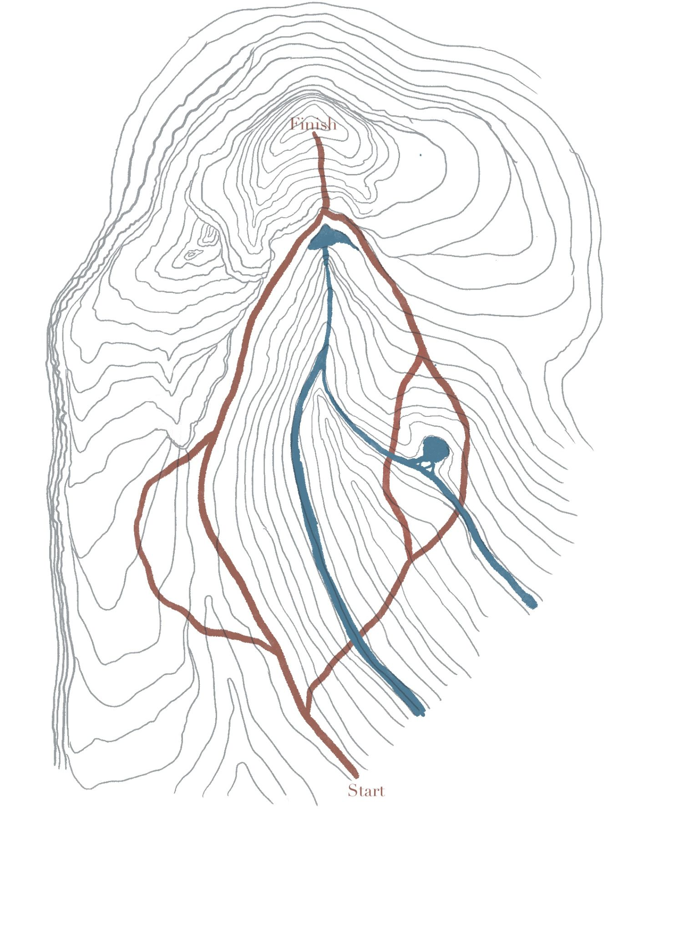

Websites with sounds - <https://mixkit.co/free-sound-effects/nature/>

<https://mixkit.co/free-sound-effects/animals/>